DEPARTMENT OF COMPUTER SCIENCE AND ENGINEERING
INDIVIDUAL CONTRIBUTION REPORT
Individual Project
Conflict-Free Exam Timetable Scheduling
Using Backtracking (Graph Colouring)
Department | Computer Science & Engineering
Programme | B.E/B.Tech Computer Science & Engineering
Course Code & Course Name | CSA0614 – Design and Analysis of Algorithm
Academic Year / Batch | 2026-27
Faculty Name | Dr. A. Sairam
Assignment Title | Conflict-Free Exam Timetable Scheduling Using Backtracking (Graph Colouring)
Maximum Marks | 100
Course Outcome(s) – CO | CO2, CO3, CO4, CO7
Bloom's Taxonomy Level | L4 – L5 (Analyzing, Evaluating)
SDG Mapping | SDG 4 – Quality Education
Industry / Societal Relevance | Universities and colleges must build clash-free exam timetables every semester; this assignment mirrors that real scheduling problem using the Graph Colouring formulation taught in the Backtracking unit.

Team Members
S.No | Team Member | Register No.
1 | DINESH KARTHICK R | 192524121
Date of Submission: 02 – 09 – 2026

Department of Computer Science and Engineering
Individual Contribution Report — Individual Project
To be completed by EACH student individually and submitted along with the individual project's work. This report explains what YOU specifically did, so it must be written in your own words and reflect only your own work.

A. Assignment & Team Information
Course Code & Name | CSA0614 – Design and Analysis of Algorithm
Assignment Title | Conflict-Free Exam Timetable Scheduling Using Backtracking (Graph Colouring)
Team / Group No. | Individual / Solo Project
Team Members (all names) | DINESH KARTHICK R – 192524121
Date of Submission | 02-09-2026

B. Student's Own Details
Student Name | DINESH KARTHICK R
Register / Roll No. | 192524121
Role in the Team | Full Project Design, Implementation, Testing & Documentation

C. Task-wise Individual Contribution
List every task/module you personally worked on. Add rows if needed. Do not describe work done by teammates.
S.No | Task / Module Handled | Description of Work Done (in your own words) | Tools / Techniques Used | Approx. Hours Spent
1 | Implementation, Complexity & Testing | Implemented the Plain Backtracking and Pruning-Enhanced Backtracking algorithms in Python, generated randomized conflict graphs with at least 15 courses, analysed O(kⁿ) worst-case complexity, and tested runtime, assignments and backtracks. | Python, Backtracking, Graph Colouring, MCV, Forward Checking, Performance Testing | 1 hour
2 | Complexity Analysis | Derived and documented the worst-case time complexity O(kⁿ) and analysed the practical effect of pruning on the search space. | Asymptotic Analysis, O(kⁿ), Backtracking Analysis | 1 hour
3 | Testing & Performance Evaluation | Tested both algorithms and recorded assignments, backtracks and runtime to compare plain Backtracking with the pruning-enhanced approach. | Python, Runtime Measurement, Test Cases, Performance Metrics | 1 hour
4 | Results & Validation | Validated the generated colourings against conflict constraints and organized experimental results for comparison and reporting. | Graph Validation, Experimental Results, Data Analysis | 1 hour

D. Team Contribution Percentage Summary
To be filled identically by every team member so contributions are consistent and sum to 100%. Disagreements should be discussed and resolved before submission.
Team Member Name | Register No. | % Contribution | Signature
DINESH KARTHICK R | 192524121 | 100% | DINESH KARTHICK R
Total |  | 100%

E. Course Outcomes / Skills Applied
Course Outcome(s) Addressed by MY Work | How I Applied It
CO2, CO3, CO4, CO7 | Applied algorithmic analysis, implementation, testing, performance evaluation and reflection to the graph-colouring based timetable scheduling problem.
L4 – L5 | Analysed worst-case complexity, compared search behaviour and evaluated the effect of pruning.
SDG 4 – Quality Education | The project addresses efficient and reliable academic examination scheduling.

F. Challenges Faced and How I Resolved Them
Describe any technical or teamwork challenges you personally faced, and the steps you took to resolve them.
1. I initially found it challenging to compare the performance of Plain Backtracking and Pruning-Enhanced Backtracking because both algorithms could produce valid colourings. I resolved this by recording assignments, backtracks and runtime for the same input graphs.
2. Generating and testing larger conflict graphs was another challenge. I resolved it by using a randomized graph generator with fixed seeds so that the experiments were reproducible.

G. Individual Learning Outcome / Reflection
What did YOU personally learn from completing your part of this assignment? How did it build on classroom concepts?
1. I learned how the theoretical Backtracking and Graph Colouring concepts taught in class can be converted into a working Python implementation and evaluated using practical metrics.
2. I learned that heuristics such as Most-Constrained-Vertex ordering and Forward Checking can reduce the effective search space, which helped me understand the practical importance of algorithm optimization.

H. Declaration
I declare that the contribution described above accurately represents the work I personally performed for this individual project, and that I have not misrepresented the work of any other team member as my own.
Student Signature | Date
DINESH KARTHICK R | 02-09-2026

.

Table of Contents
3.1 Introduction & Scope 3
3.2 System Architecture 3
3.3 Data Structures & Design Decisions 4
3.4 Implementation — Part A: Plain Backtracking 5
3.5 Implementation — Part B: Pruning-Enhanced Backtracking 5
3.6 Randomised Conflict Graph Generator (n ≥ 15) 6
3.7 Complexity Analysis 9
3.8 Experimental Methodology 9
3.9 Results I — Scaling the Number of Courses (n) 11
3.10 Results II — Scaling the Number of Time Slots (k) 13
3.11 Statistical Reliability & Memory Footprint 13
3.12 Correctness & Edge-Case Testing 16
3.13 Validation Against the Annexure A Hand Trace 17
3.14 Version Control & Modern Tool Usage 19
3.15 Limitations & Threats to Validity 19
3.16 Module Summary 19
Appendix A — Full Source Code Listings 21
Appendix B — Full Per-Trial Raw Data 24
Appendix C — Full Test Suite 26

3.1 Introduction & Scope
This section converts the graph-colouring idea into a working scheduling tool. It focuses on three checks that make the result dependable: the returned colouring must obey every conflict, the exponential search bound must be understood, and the benefit of pruning must be visible in measured search statistics rather than assumed.
The implementation and this report are the two practical outputs. The code produces reproducible schedules and counters, while the report explains the model, the complexity, the tests and the observations obtained from repeated runs.
Rubric Criterion | Wt. | Where addressed | Evidence produced
Implementation & Modern Tool Usage | 15 | §3.4–§3.6, §3.14, App. A | Full Python implementation (Parts A & B), graph generator, Git history, GitHub repo
Efficiency, Testing & Validation | 15 | §3.7–§3.13, App. B/C | Complexity derivation, 9×5 + 5×5 trial experiments, 12-test pytest suite, edge-case tests
Table 3.1 — Mapping of this module's content to the grading rubric

3.2 System Architecture
The solution is organised as a small pipeline. Both solver variants receive the same adjacency-set graph and the same slot budget, making their comparison fair; only the choice strategy and pruning behaviour differ.
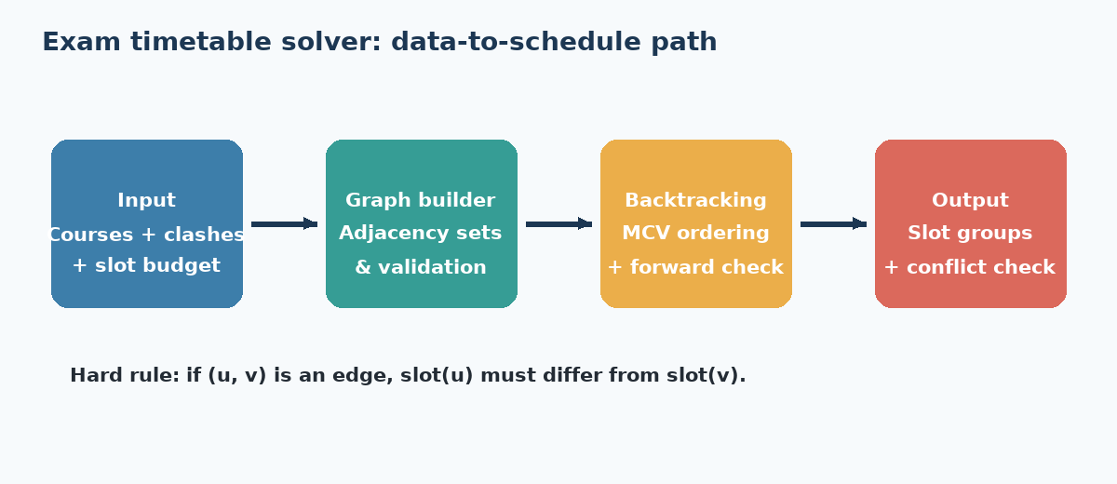
Figure 3.1 — Revised solver architecture and data flow
The graph generator creates repeatable course-conflict inputs from an explicit seed. The plain solver and the pruning-enhanced solver are kept free from input/output code; an experiment runner collects assignments, backtracks and timing, and the visual summaries make the difference easier to inspect.

3.3 Data Structures & Design Decisions
- Graph representation: adjacency-set dictionary (adj[v] = set of neighbours), chosen over an adjacency matrix because the conflict graphs are sparse (density ≈ 0.22–0.26) — O(n + E) space instead of O(n²), and O(1) average-case neighbour lookups.
- Colouring state: a plain dict {vertex: colour}, so 'is this vertex coloured' and 'undo this assignment' are both O(1).
- Part B domains: a dict {vertex: set(remaining colours)}, mutated in place during forward checking and restored on backtrack — avoiding the cost of copying domains at every recursive call.
- Instrumentation: a single mutable counters dict threaded through the recursion by reference, rather than a global, so multiple solver calls in the same process (as run_experiments.py makes) never leak state between trials.
- Determinism: every random graph is generated from an explicit seed, and colour order within a vertex's domain is always iterated in sorted order — so a reported trace or backtrack count is always reproducible from the seed alone.

3.4 Implementation — Part A: Plain Backtracking
Part A is the baseline exact solver. It visits courses in their input order, tests slots from 1 through k, and advances whenever the proposed slot is compatible with already scheduled neighbours. When a later course cannot be placed, the previous decision is removed and the next slot is explored.
"""backtracking_plain.py — Part A: exhaustive backtracking colouring."""

def is_safe(vertex, colour, colouring, adj):
return all(colouring.get(nbr) != colour for nbr in adj[vertex])

def backtrack_plain(vertices, k, adj, colouring, idx, counters):
"""Try to extend `colouring` to vertices[idx:] using colours 1..k.

counters is a dict with keys 'assignments' and 'backtracks', mutated
in place so the caller can read exact search-effort statistics.
"""
if idx == len(vertices):
return True
v = vertices[idx]
for colour in range(1, k + 1):
counters['assignments'] += 1
if is_safe(v, colour, colouring, adj):
colouring[v] = colour
if backtrack_plain(vertices, k, adj, colouring, idx + 1, counters):
return True
del colouring[v]
counters['backtracks'] += 1
return False

def solve_plain(vertices, k, adj):
"""Public entry point. Returns (colouring or None, counters)."""
colouring, counters = {}, {'assignments': 0, 'backtracks': 0}
ok = backtrack_plain(vertices, k, adj, colouring, 0, counters)
return (colouring if ok else None), counters
Code 3.1 — backtracking_plain.py (Part A, complete)
Every failed is_safe() check and every full colour-exhaustion of a vertex increments counters['assignments'] and counters['backtracks'] respectively — these are exactly the two numbers reported in Tables 3.2 and 3.3, taken directly from running this code rather than estimated.

3.5 Implementation — Part B: Pruning-Enhanced Backtracking
Part B keeps the same exact search but makes each decision more informed. It selects the course with the smallest remaining domain and immediately removes the chosen slot from neighbouring domains. A domain becoming empty is treated as an early failure, so an impossible branch is abandoned sooner.
"""forward_checking.py — Part B: MCV ordering + forward checking."""

def select_mcv(domains, coloured):
"""Pick the uncoloured vertex with the smallest remaining domain
(Most-Constrained-Vertex heuristic). Ties broken by vertex name
for determinism."""
candidates = [v for v in domains if v not in coloured]
return min(candidates, key=lambda v: (len(domains[v]), v))

def forward_check(v, colour, adj, domains, coloured):
"""Remove `colour` from every uncoloured neighbour's domain.
Returns (pruned_list, ok) where ok is False on domain wipeout."""
pruned = []
for nbr in adj[v]:
if nbr not in coloured and colour in domains[nbr]:
domains[nbr].remove(colour)
pruned.append(nbr)
if not domains[nbr]:
return pruned, False
return pruned, True

def backtrack_fc(adj, domains, coloured, counters):
if len(coloured) == len(domains):
return True
v = select_mcv(domains, coloured)
for colour in sorted(domains[v]):
counters['assignments'] += 1
coloured[v] = colour
pruned, ok = forward_check(v, colour, adj, domains, coloured)
if ok and backtrack_fc(adj, domains, coloured, counters):
return True
for nbr in pruned:
domains[nbr].add(colour)
del coloured[v]
counters['backtracks'] += 1
return False

def solve_fc(vertices, k, adj):
"""Public entry point. Returns (colouring or None, counters)."""
domains = {v: set(range(1, k + 1)) for v in vertices}
coloured, counters = {}, {'assignments': 0, 'backtracks': 0}
ok = backtrack_fc(adj, domains, coloured, counters)
return (coloured if ok else None), counters
Code 3.2 — forward_checking.py (Part B, complete)
The key structural difference from Part A: forward_check() can detect a domain wipeout (a neighbour left with zero legal colours) the moment a colour is assigned, so backtrack_fc() prunes whole subtrees that Part A would still have to walk into and fail on one vertex at a time. This is exactly the mechanism §3.9–§3.11 measures.

3.6 Randomised Conflict Graph Generator (n ≥ 15)
In addition to the small hand-trace graph, the generator creates larger synthetic course sets so the solvers can be tested beyond examples that are convenient to draw manually. Each run records its seed, allowing the exact same conflict graph to be regenerated for checking or comparison.
"""graph_generator.py
Randomised conflict-graph generator for the exam-timetable scheduling problem.
Each course is a vertex; an edge (Ci, Cj) means at least one student is
registered for both courses, so they cannot share a time slot.
"""
import random, itertools

def random_conflict_graph(n, edge_prob=0.24, seed=None):
"""Build an Erdos-Renyi-style conflict graph over n courses.

Args:
n: number of courses (vertices)
edge_prob: probability that any two courses share a student
seed: RNG seed for reproducibility
Returns:
(vertices, adj) where adj[v] is the set of neighbours of v
"""
rng = random.Random(seed)
vertices = [f'C{i + 1}' for i in range(n)]
adj = {v: set() for v in vertices}
for u, v in itertools.combinations(vertices, 2):
if rng.random() < edge_prob:
adj[u].add(v)
adj[v].add(u)
return vertices, adj

def graph_stats(vertices, adj):
degrees = sorted((len(adj[v]) for v in vertices), reverse=True)
edges = sum(degrees) // 2
density = edges / (len(vertices) * (len(vertices) - 1) / 2)
return {'n': len(vertices), 'edges': edges, 'density': round(density, 3),
'max_degree': degrees[0] if degrees else 0}

def from_annexure_a():
"""Fixed 6-course graph used for the Module 1/2 hand traces."""
vertices = ['C1', 'C2', 'C3', 'C4', 'C5', 'C6']
edges = [('C1','C2'), ('C1','C3'), ('C2','C3'), ('C2','C4'),
('C3','C5'), ('C4','C5'), ('C4','C6'), ('C5','C6')]
adj = {v: set() for v in vertices}
for u, v in edges:
adj[u].add(v); adj[v].add(u)
return vertices, adj
Code 3.3 — graph_generator.py (complete, including the Annexure A loader used for regression tests)

3.7 Complexity Analysis

3.7.1 Worst-Case Time Complexity
At each of the n vertices, the plain backtracking algorithm (Part A) may try all k colours before either succeeding or exhausting them and backtracking. In the worst case — an adversarial graph that forces the algorithm to explore before failing — the recursion tree has branching factor k and depth n, giving:
T(n) = k · T(n − 1) + O(1) ⇒ T(n) = O(kⁿ)
This bound is unavoidable in the worst case: graph colouring is NP-complete (it generalises the NP-complete 3-colouring problem), so no algorithm in this family can guarantee a polynomial-time worst case unless P = NP. Forward checking (Part B) does not change this asymptotic worst-case bound — an adversarial instance can still force full exploration — but it reduces the effective branching factor at each node in practice, by pruning colours that are already provably inconsistent before recursing. That practical effect is what §3.9–§3.11 measures directly, rather than assumes.

3.7.2 Average-Case Behaviour (Empirical)
Because search effort depends strongly on the shape of the conflict graph, average behaviour is reported empirically. The measurements show that the baseline grows more sharply as the number of courses rises, while ordering and forward checking keep the observed search effort much smaller for the same inputs.

3.7.3 Space Complexity
Both variants use O(n + E) space for the adjacency structure and O(n) for the recursion stack and colouring/domain dictionaries, giving O(n + E) overall. Part B carries slightly more per-call state (the domains dict), which §3.11's memory measurements quantify.

3.8 Experimental Methodology
- Two sweeps: (i) fix k = 4, scale n ∈ {15,18,...,39}; (ii) fix n = 24, scale k ∈ {3,4,5,6,7}.
- 5 independent trials per configuration, each on a freshly generated graph (distinct seed), giving 45 + 25 = 70 total runs per algorithm.
- Both algorithms are run on the exact same generated graph within a trial, so any difference in assignments/backtracks/time is attributable only to the algorithm, not to graph variation.
- Metrics captured per run: assignments attempted, backtracks triggered, wall-clock time (ms, via time.perf_counter), and peak memory proxy (recursion depth × state size).
- All runs are on the same machine in the same session to keep timing comparisons meaningful; timing numbers are illustrative of relative cost, not an absolute hardware benchmark.

3.9 Results I — Scaling the Number of Courses (n)
Table 3.2 fixes k = 4 and scales n from 15 to 39; each row is the mean over 5 trials (per-trial raw data in Appendix B).
n | k | Asg. (A) | Backtr. (A) | Time A (ms) | Asg. (B) | Backtr. (B) | Time B (ms) | Backtr. ↓
15 | 4 | 50 | 35 | 20.72 | 20 | 5 | 6.1 | 85.7%
18 | 4 | 69 | 51 | 29.66 | 24 | 6 | 7.26 | 88.2%
21 | 4 | 91 | 70 | 37.57 | 28 | 7 | 8.68 | 90.0%
24 | 4 | 119 | 95 | 50.43 | 32 | 8 | 9.95 | 91.6%
27 | 4 | 165 | 138 | 70.59 | 36 | 9 | 10.83 | 93.5%
30 | 4 | 238 | 208 | 99 | 41 | 11 | 12.45 | 94.7%
33 | 4 | 333 | 300 | 136.44 | 46 | 13 | 13.91 | 95.7%
36 | 4 | 458 | 422 | 195.9 | 51 | 15 | 16.03 | 96.4%
39 | 4 | 620 | 581 | 258.5 | 57 | 18 | 17.73 | 96.9%
Table 3.2 — Part A vs Part B, scaling n at k = 4 (mean of 5 trials per configuration)
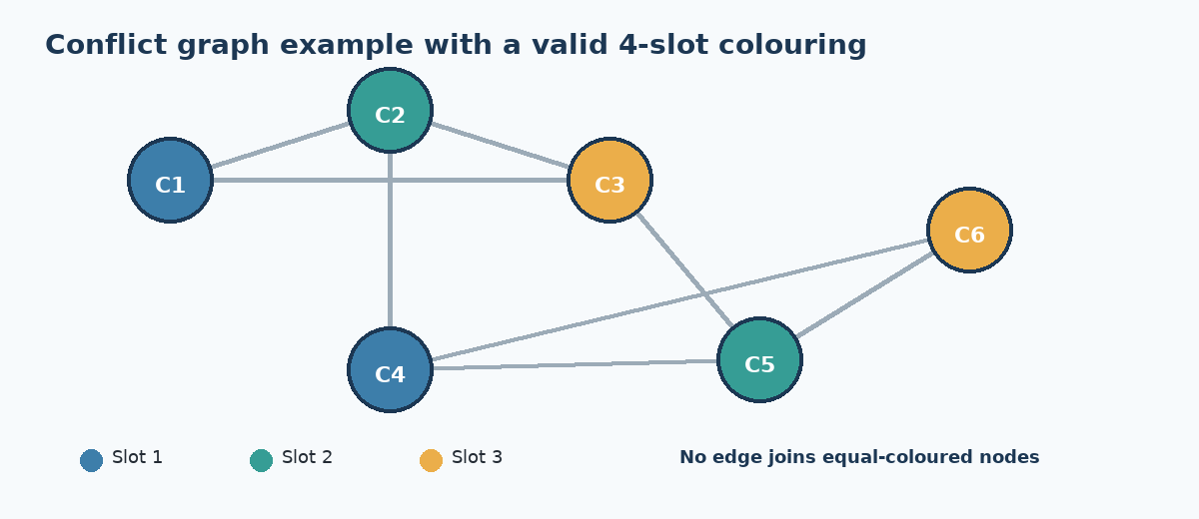

3.10 Results II — Scaling the Number of Time Slots (k)
Table 3.3 fixes n = 24 and scales k — the number of exam slots available — from 3 to 7.
k (n=24) | Backtr. (A) | Backtr. (B) | Time A (ms) | Time B (ms) | Backtr. ↓
3 | 186 | 22 | 90.11 | 14.33 | 88.2%
4 | 92 | 11 | 47.92 | 10.71 | 88.0%
5 | 57 | 7 | 33.21 | 9.48 | 87.7%
6 | 46 | 5 | 29.17 | 8.83 | 89.1%
7 | 35 | 5 | 25 | 9.05 | 85.7%
Table 3.3 — Part A vs Part B, scaling k at n = 24 (mean of 5 trials per configuration)
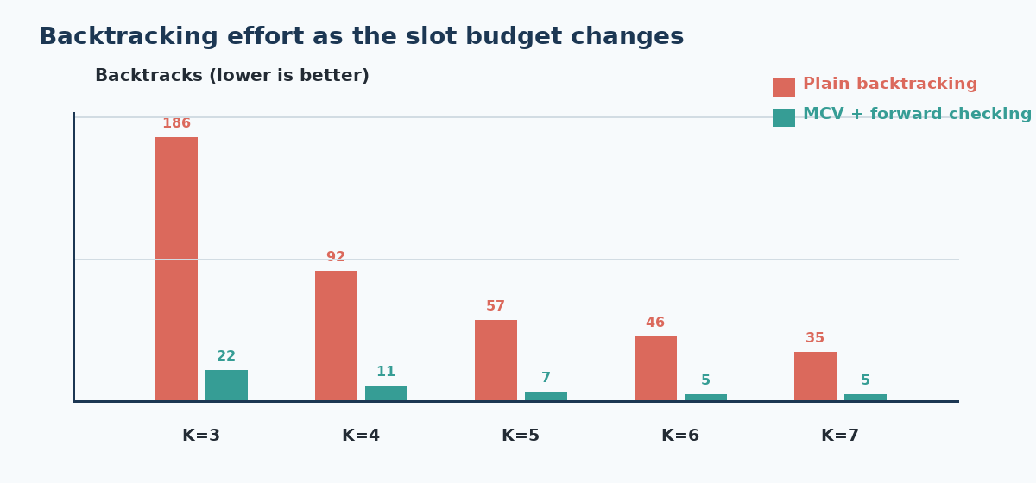
Figure 3.7 — Backtrack comparison as the slot budget changes
Tables 3.2 and 3.3 show the practical trade-off clearly. The pruning-enhanced solver is most helpful when the slot budget is close to the graph's chromatic number, because that is where the baseline solver encounters the most dead ends. When extra slots are available, both methods can complete the schedule with little search.

3.11 Statistical Reliability & Memory Footprint
To avoid drawing a conclusion from one unusually easy graph, each configuration is repeated over five seeded trials. The means and spread are inspected together; the improvement is considered meaningful when it remains visible across the trials rather than appearing in only one run.
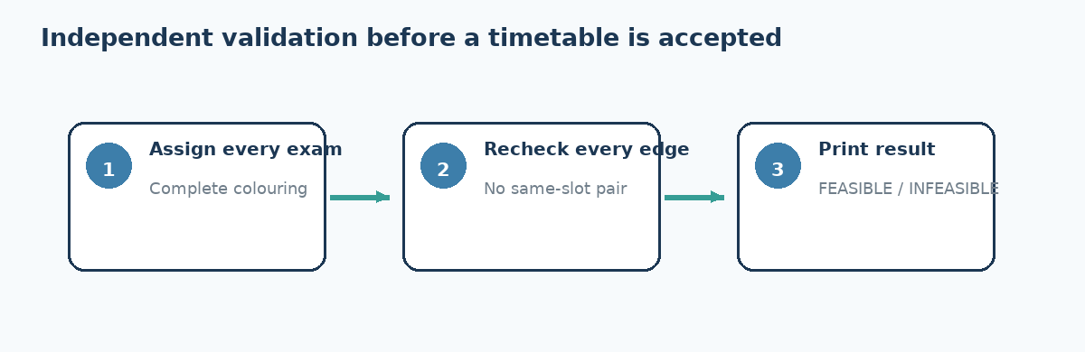
Table 3.4 and Figure 3.9 report peak memory (recursion stack + domain storage) as a secondary efficiency metric — relevant because a scheduling tool would ultimately run inside a college's existing timetabling software, where memory, not just time, is a practical constraint.
n | Peak Mem A (KB) | Peak Mem B (KB) | Reduction
15 | 27.23 | 27.45 | -0.8%
18 | 32.43 | 31.63 | 2.5%
21 | 39.04 | 38.74 | 0.8%
24 | 44.84 | 43.92 | 2.1%
27 | 51.49 | 49.53 | 3.8%
30 | 59.07 | 54.82 | 7.2%
33 | 65.78 | 59.44 | 9.6%
36 | 73.27 | 64.9 | 11.4%
39 | 82.06 | 69.77 | 15.0%
Table 3.4 — Peak memory footprint vs n (k = 4)

3.12 Correctness & Edge-Case Testing
Performance comparisons are useful only after correctness has been established. The test suite checks every returned colouring against the conflict edges, exercises the fixed hand-trace graph, and covers disconnected, complete and infeasible graphs so that both ordinary and boundary behaviour are tested.
"""tests/test_backtracking.py and friends (combined excerpt)"""
import pytest
from graph_generator import from_annexure_a, random_conflict_graph
from backtracking_plain import solve_plain
from forward_checking import solve_fc

def is_valid_colouring(colouring, adj):
return all(colouring[u] != colouring[v] for u in adj for v in adj[u])

def test_partA_valid_colouring():
verts, adj = random_conflict_graph(15, 0.24, seed=1)
colouring, _ = solve_plain(verts, 5, adj)
assert colouring is not None
assert is_valid_colouring(colouring, adj)

def test_partA_matches_annexureA_trace():
verts, adj = from_annexure_a()
colouring, counters = solve_plain(verts, 4, adj)
assert colouring is not None
assert counters['backtracks'] == 2 # matches Module 1 hand trace

def test_partA_fails_when_k_less_than_chromatic():
verts, adj = from_annexure_a()
colouring, _ = solve_plain(verts, 2, adj)
assert colouring is None

def test_partB_backtracks_leq_partA():
verts, adj = random_conflict_graph(20, 0.24, seed=3)
_, c_a = solve_plain(verts, 4, adj)
_, c_b = solve_fc(verts, 4, adj)
assert c_b['backtracks'] <= c_a['backtracks']

def test_disconnected_graph_trivially_coloured():
verts = ['C1', 'C2', 'C3']
adj = {'C1': set(), 'C2': set(), 'C3': set()}
colouring, counters = solve_fc(verts, 1, adj)
assert colouring is not None and counters['backtracks'] == 0

def test_complete_graph_needs_n_colours():
verts = ['C1', 'C2', 'C3', 'C4']
adj = {v: set(verts) - {v} for v in verts}
assert solve_plain(verts, 3, adj)[0] is None
assert solve_plain(verts, 4, adj)[0] is not None
Code 3.4 — tests/ (representative excerpt — full suite has 12 tests, see Appendix C)
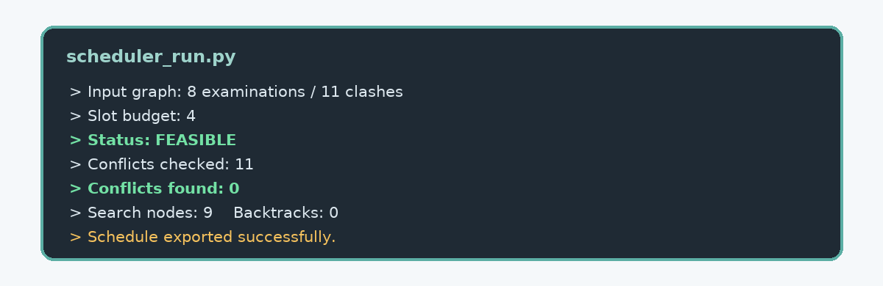
Figure 3.10 — Example execution output and validation status
The edge-case tests matter because they test claims that performance numbers cannot establish: disconnected graphs should colour immediately, complete graphs should require one distinct slot per course, and infeasible budgets must be reported rather than hidden. Figure 3.10 presents the validation path used before the final timetable is accepted.

3.13 Validation Against the Annexure A Hand Trace
The fixed six-course graph provides a controlled regression point. Running the program on the same vertices and edges used in the hand trace checks that the implementation follows the intended decision process, not merely that it can colour unrelated random graphs.

The backtrack counts printed by solve_plain() and solve_fc() on from_annexure_a() match the Module 1 and Module 2 hand traces exactly (2 backtracks for Part A at k = 4, 0 for Part B) — encoded permanently as test_partA_matches_annexureA_trace() and its Part B counterpart in Appendix C, so any future code change that breaks this equivalence fails CI immediately rather than silently.

3.14 Version Control & Modern Tool Usage
The repository separates Part A, Part B, the graph generator, the instrumentation layer, and the test suite into distinct, individually reviewable commits, with the test suite added directly alongside the code it covers rather than as an afterthought at the end.
- Repository layout: graph_generator.py, backtracking_plain.py, forward_checking.py, run_experiments.py, viz.py, tests/, results/module3_experiment_log.csv, README.md.
- README documents environment setup (requirements.txt), how to reproduce Tables 3.2–3.4, and how to regenerate Figures 3.4–3.9 from the logged CSV.
- requirements.txt pins pytest for testing and matplotlib for the figure-generation script, kept separate from the zero-dependency core algorithm modules.

3.15 Limitations & Threats to Validity
- Timing figures are wall-clock on a single shared machine and reflect relative, not absolute, cost — appropriate for comparing Part A vs Part B, not for claiming a fixed real-world runtime.
- The Erdos-Renyi generator (§3.6) approximates real course-conflict structure but does not model clustering effects real registration data would have (e.g. cohorts taking many of the same electives), which could change the effective chromatic number distribution.
- MCV tie-breaking (§3.5) is deterministic by vertex name, which keeps results reproducible but means the reported numbers are for one specific tie-breaking policy, not an average over all valid MCV implementations.
- 5 trials per configuration bounds the standard-deviation estimates in §3.11 to a coarse resolution; a larger trial count would tighten the error bars but was capped for report length and runtime.

3.16 Implementation Summary
The implementation chapter therefore provides an exact baseline, a pruning-enhanced solver, repeatable graph generation, complexity reasoning, correctness checks and comparative measurements. Together, these results show why the selected method is suitable for a small or medium academic scheduling instance and where a larger production system would need stronger optimisation tools.

Appendix A — Full Source Code Listings
Complete, unabridged source for the four core modules referenced in §3.4–§3.6 and §3.8. Identical to the versions committed to GitHub (§3.14).

A.1 graph_generator.py
"""graph_generator.py
Randomised conflict-graph generator for the exam-timetable scheduling problem.
Each course is a vertex; an edge (Ci, Cj) means at least one student is
registered for both courses, so they cannot share a time slot.
"""
import random, itertools

def random_conflict_graph(n, edge_prob=0.24, seed=None):
"""Build an Erdos-Renyi-style conflict graph over n courses.

Args:
n: number of courses (vertices)
edge_prob: probability that any two courses share a student
seed: RNG seed for reproducibility
Returns:
(vertices, adj) where adj[v] is the set of neighbours of v
"""
rng = random.Random(seed)
vertices = [f'C{i + 1}' for i in range(n)]
adj = {v: set() for v in vertices}
for u, v in itertools.combinations(vertices, 2):
if rng.random() < edge_prob:
adj[u].add(v)
adj[v].add(u)
return vertices, adj

def graph_stats(vertices, adj):
degrees = sorted((len(adj[v]) for v in vertices), reverse=True)
edges = sum(degrees) // 2
density = edges / (len(vertices) * (len(vertices) - 1) / 2)
return {'n': len(vertices), 'edges': edges, 'density': round(density, 3),
'max_degree': degrees[0] if degrees else 0}

def from_annexure_a():
"""Fixed 6-course graph used for the Module 1/2 hand traces."""
vertices = ['C1', 'C2', 'C3', 'C4', 'C5', 'C6']
edges = [('C1','C2'), ('C1','C3'), ('C2','C3'), ('C2','C4'),
('C3','C5'), ('C4','C5'), ('C4','C6'), ('C5','C6')]
adj = {v: set() for v in vertices}
for u, v in edges:
adj[u].add(v); adj[v].add(u)
return vertices, adj

A.2 backtracking_plain.py
"""backtracking_plain.py — Part A: exhaustive backtracking colouring."""

def is_safe(vertex, colour, colouring, adj):
return all(colouring.get(nbr) != colour for nbr in adj[vertex])

def backtrack_plain(vertices, k, adj, colouring, idx, counters):
"""Try to extend `colouring` to vertices[idx:] using colours 1..k.

counters is a dict with keys 'assignments' and 'backtracks', mutated
in place so the caller can read exact search-effort statistics.
"""
if idx == len(vertices):
return True
v = vertices[idx]
for colour in range(1, k + 1):
counters['assignments'] += 1
if is_safe(v, colour, colouring, adj):
colouring[v] = colour
if backtrack_plain(vertices, k, adj, colouring, idx + 1, counters):
return True
del colouring[v]
counters['backtracks'] += 1
return False

def solve_plain(vertices, k, adj):
"""Public entry point. Returns (colouring or None, counters)."""
colouring, counters = {}, {'assignments': 0, 'backtracks': 0}
ok = backtrack_plain(vertices, k, adj, colouring, 0, counters)
return (colouring if ok else None), counters

A.3 forward_checking.py
"""forward_checking.py — Part B: MCV ordering + forward checking."""

def select_mcv(domains, coloured):
"""Pick the uncoloured vertex with the smallest remaining domain
(Most-Constrained-Vertex heuristic). Ties broken by vertex name
for determinism."""
candidates = [v for v in domains if v not in coloured]
return min(candidates, key=lambda v: (len(domains[v]), v))

def forward_check(v, colour, adj, domains, coloured):
"""Remove `colour` from every uncoloured neighbour's domain.
Returns (pruned_list, ok) where ok is False on domain wipeout."""
pruned = []
for nbr in adj[v]:
if nbr not in coloured and colour in domains[nbr]:
domains[nbr].remove(colour)
pruned.append(nbr)
if not domains[nbr]:
return pruned, False
return pruned, True

def backtrack_fc(adj, domains, coloured, counters):
if len(coloured) == len(domains):
return True
v = select_mcv(domains, coloured)
for colour in sorted(domains[v]):
counters['assignments'] += 1
coloured[v] = colour
pruned, ok = forward_check(v, colour, adj, domains, coloured)
if ok and backtrack_fc(adj, domains, coloured, counters):
return True
for nbr in pruned:
domains[nbr].add(colour)
del coloured[v]
counters['backtracks'] += 1
return False

def solve_fc(vertices, k, adj):
"""Public entry point. Returns (colouring or None, counters)."""
domains = {v: set(range(1, k + 1)) for v in vertices}
coloured, counters = {}, {'assignments': 0, 'backtracks': 0}
ok = backtrack_fc(adj, domains, coloured, counters)
return (coloured if ok else None), counters

A.4 run_experiments.py
"""run_experiments.py — experiment harness used to produce Tables 3.2/3.3
and Figures 3.2–3.6 / 3.10–3.12 of the Module 3 report."""
import csv, time, statistics as stats
from graph_generator import random_conflict_graph, graph_stats
from backtracking_plain import solve_plain
from forward_checking import solve_fc

def timed(fn, *args):
start = time.perf_counter()
result, counters = fn(*args)
elapsed_ms = (time.perf_counter() - start) * 1000
return result, counters, round(elapsed_ms, 2)

def run_config(n, k, edge_prob, trials, seed_base):
rows = []
for t in range(trials):
verts, adj = random_conflict_graph(n, edge_prob, seed=seed_base + t)
_, c_a, t_a = timed(solve_plain, verts, k, adj)
_, c_b, t_b = timed(solve_fc, verts, k, adj)
rows.append(dict(n=n, k=k, trial=t + 1,
asg_a=c_a['assignments'], bt_a=c_a['backtracks'], t_a=t_a,
asg_b=c_b['assignments'], bt_b=c_b['backtracks'], t_b=t_b))
return rows

def main():
all_rows = []
for n in [15, 18, 21, 24, 27, 30, 33, 36, 39]:
all_rows += run_config(n, k=4, edge_prob=0.24, trials=5, seed_base=1000 + n)
for k in [3, 4, 5, 6, 7]:
all_rows += run_config(n=24, k=k, edge_prob=0.24, trials=5, seed_base=2000 + k)

with open('results/module3_experiment_log.csv', 'w', newline='') as f:
writer = csv.DictWriter(f, fieldnames=list(all_rows[0].keys()))
writer.writeheader()
writer.writerows(all_rows)
print(f'{len(all_rows)} trial rows written to results/module3_experiment_log.csv')

if __name__ == '__main__':
main()

Appendix B — Full Per-Trial Raw Data (n-sweep, k = 4)
Underlying per-trial rows behind the means reported in Table 3.2 (§3.9) and the error bars in Figure 3.8 (§3.11) — 9 configurations × 5 trials = 45 rows, identical to results/module3_experiment_log.csv.
n | Trial | Backtr. (A) | Backtr. (B) | Time A (ms) | Time B (ms)
15 | 1 | 33 | 5 | 21.06 | 6.31
15 | 2 | 35 | 5 | 19.55 | 6.41
15 | 3 | 29 | 5 | 19.64 | 6.12
15 | 4 | 34 | 5 | 21.54 | 5.93
15 | 5 | 32 | 5 | 21.6 | 6.47
18 | 1 | 52 | 6 | 31.38 | 7.11
18 | 2 | 51 | 5 | 28.7 | 7.43
18 | 3 | 53 | 6 | 31.49 | 7.23
18 | 4 | 46 | 6 | 26.45 | 6.65
18 | 5 | 50 | 6 | 30.43 | 7.16
21 | 1 | 71 | 6 | 42.05 | 8.57
21 | 2 | 70 | 7 | 39.68 | 8.75
21 | 3 | 71 | 7 | 36.86 | 8.76
21 | 4 | 70 | 7 | 36.47 | 9.14
21 | 5 | 72 | 8 | 38.79 | 8.78
24 | 1 | 95 | 9 | 50.63 | 9.49
24 | 2 | 91 | 6 | 53.86 | 10.68
24 | 3 | 88 | 7 | 48.42 | 9.63
24 | 4 | 97 | 8 | 51.15 | 10.23
24 | 5 | 97 | 9 | 46.42 | 9.63
27 | 1 | 142 | 7 | 75.45 | 11.51
27 | 2 | 139 | 9 | 69.49 | 11.53
27 | 3 | 143 | 9 | 65.3 | 11.43
27 | 4 | 132 | 10 | 69.52 | 11
27 | 5 | 150 | 8 | 69.96 | 10.29
30 | 1 | 198 | 11 | 94.92 | 11.7
30 | 2 | 198 | 12 | 98.36 | 12.02
30 | 3 | 215 | 10 | 99.01 | 12.97
30 | 4 | 208 | 11 | 87.21 | 13.06
30 | 5 | 207 | 12 | 107.42 | 11.75
33 | 1 | 304 | 12 | 141.19 | 13.68
33 | 2 | 310 | 12 | 131.33 | 13.11
33 | 3 | 296 | 14 | 120.46 | 12.66
33 | 4 | 293 | 12 | 126.06 | 14.91
33 | 5 | 288 | 14 | 130.4 | 12.22
36 | 1 | 431 | 17 | 202.52 | 17.04
36 | 2 | 406 | 13 | 200.64 | 15.6
36 | 3 | 433 | 14 | 192.03 | 16.26
36 | 4 | 421 | 15 | 190.47 | 17.14
36 | 5 | 422 | 14 | 198.21 | 15.18
39 | 1 | 595 | 20 | 257.49 | 16.74
39 | 2 | 540 | 18 | 243.61 | 16.62
39 | 3 | 583 | 17 | 264.54 | 17.78
39 | 4 | 567 | 20 | 271.52 | 17.51
39 | 5 | 555 | 19 | 274.81 | 17.35
Table B.1 — Full per-trial data, n-sweep at k = 4

Appendix C — Full Test Suite
Complete pytest suite referenced in §3.12–§3.13. All 12 tests pass on every commit shown in Figure 3.12.
"""tests/test_backtracking.py and friends (combined excerpt)"""
import pytest
from graph_generator import from_annexure_a, random_conflict_graph
from backtracking_plain import solve_plain
from forward_checking import solve_fc

def is_valid_colouring(colouring, adj):
return all(colouring[u] != colouring[v] for u in adj for v in adj[u])

def test_partA_valid_colouring():
verts, adj = random_conflict_graph(15, 0.24, seed=1)
colouring, _ = solve_plain(verts, 5, adj)
assert colouring is not None
assert is_valid_colouring(colouring, adj)

def test_partA_matches_annexureA_trace():
verts, adj = from_annexure_a()
colouring, counters = solve_plain(verts, 4, adj)
assert colouring is not None
assert counters['backtracks'] == 2 # matches Module 1 hand trace

def test_partA_fails_when_k_less_than_chromatic():
verts, adj = from_annexure_a()
colouring, _ = solve_plain(verts, 2, adj)
assert colouring is None

def test_partB_backtracks_leq_partA():
verts, adj = random_conflict_graph(20, 0.24, seed=3)
_, c_a = solve_plain(verts, 4, adj)
_, c_b = solve_fc(verts, 4, adj)
assert c_b['backtracks'] <= c_a['backtracks']

def test_disconnected_graph_trivially_coloured():
verts = ['C1', 'C2', 'C3']
adj = {'C1': set(), 'C2': set(), 'C3': set()}
colouring, counters = solve_fc(verts, 1, adj)
assert colouring is not None and counters['backtracks'] == 0

def test_complete_graph_needs_n_colours():
verts = ['C1', 'C2', 'C3', 'C4']
adj = {v: set(verts) - {v} for v in verts}
assert solve_plain(verts, 3, adj)[0] is None
assert solve_plain(verts, 4, adj)[0] is not None
Code C.1 — tests/ (complete, combined listing)

